|  |  |  |  |
| --- | --- | --- | --- |
|  | **C:\Users\Faisal\Desktop\Maharaja-Sayajirao-University.jpg.pagespeed.ce.uWYz99SLMS.jpgF:\Faisal\MSC ST\TGMC\tgmcfiles\tgmc logo.PNG**  **The Maharaja Sayajirao University of Baroda.**  **Software Requirement Specification**  **Criminal Record Management** | Team Members  Zoebali Maknojia  Faisal Tai  Nikki Punjabi  Sangeeta Jivanani |  |

Project Guide

Dr. Vipul Kalamkar

**Associate director M.Sc. in software technology program**

Table of Contents

1. Introduction 3

1.1 Methodology 3

1.2 Purpose 4

1.3 Scope 4

1.4 Definitions, Acronyms and Abbreviations 5

1.5 Tools Used 6

1.6 References 7

1.7 Technologies to be used 7

1.8 Overview 7

2 Overall Perspective………………………………………………………………………………………………………………………………9

2.1 Product Perspective 9

2.2 Software Interface Client on Internet 9

2.3 Hardware Interface 10

2.4 Communication Interface 11

2.5 Constraints 11

2.6 ER Diagram 12

2.7 Use Case Reports 13

3 Diagrams……………………………………………………………………………………………………………………………………………19

3.1 Activity Diagrams 18

# 1. Introduction

## 1.1 Methodology

Rational Unified Process

The Rational Unified Process brings together elements from all of the generic process models, supports iteration and illustrates good practice in specification and design. The RUP is normally described from three perspectives:

A ***dynamic perspective*** that shows the phases of the model over time.

A ***static perspective*** that shows the process activities that are enacted.

A ***practice perspective*** that suggests good practices to be used during the process.

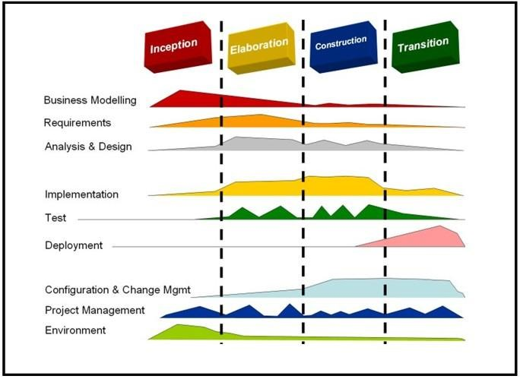

Fig 1.1:Phases of RUP

The different phases in RUP are

**Inception**

The goal of the inception phase is to establish a business case for the system. Identifying all external entities that will interact with the system and defining this interaction. This information is used to assess the contribution of system to business.

**Elaboration**

The goals of the elaboration phase are to develop an understanding of the problem domain, establish an architectural framework, develop project plan and identify key project risks.

**Construction**

This phase is concerned with system design, programming and testing. Parts of the system are developed in parallel and integrated during this phase.

**Transition**

This is the final phase of RUP and is concerned with moving the system from the development community to the user community and making it work in real environment.

## 1.2 Purpose

CMS is Web application which will allow High Authorities to maintain Criminal Records.

This application will maintain the records of all the criminals that are in jail and provide the access to the higher authorities of the government to get information of all the criminals.

This web application is more effective, quick in providing criminal records to High Authorities as and when required.

As this is web application we need not to install it every machine..

## 1.3 Scope

* + There are five basic users – Jail Superintendent, Police Officers, CBI Officers, Administrator, Judge
  + All users have their own profiles in CRM
  + Police Officers and CBI Officers can search the criminal by Name/Blood group/type of crime/jail no/DNA/image/sketch.
  + They can access all the information of criminals.
  + Jail Superidentent can also search criminal, he can update the new crime of existing criminal, he can maintain the current location of the criminals
  + Police Officers can transfer the criminals to another jail.

## 

## 1.4 Definitions, Acronyms and Abbreviations

**CRM**

**Criminal Record Management.** It’s a web application that provides online criminal records people.

**Admin**

**Administrator**. He will maintain the database and Jail administrator..

**DB2**

**Database_2**. A database management system that provides a flexible and efficient database platform to maintain records of students, teachers, admin and dm.

**JSP**

**Java Server Pages.** It is used to create dynamic web content.

**J2EE**

**Java 2 Enterprise Edition.** A programming platform which is a part of java platform for developing and running distributed java.

**UML**

**Unified Modeling Language** is a standard languagefor writing software blueprints. The

UML may be used to visualize, specify, construct and document

**XML**

**Extensible Markup Language** is a text based format that let developers describe, deliver and exchange structured data between a range of applications to client for display and manipulation.

**HTTP**

**Hypertext Transfer Protocol.** It’s a service protocol.

**RAD**

**Rational Application Developer** is a development tool that helps to design web pages and also helps to design the diagrams like ER, Database schema diagrams and to generate DDL.

## 1.5 Tools Used

**Application architecture – JAVA, J2EE**

**JAVA**

Java is an object-oriented programming language developed by Sun Microsystems a company best known for its high end UNIX workstations. Java language was designed to be small, simple, and portable across platforms, operating systems, both at the source and at the binary level, which means that Java programs (applet and application) can run on any machine that has the Java virtual machine (JVM) installed.

**J2EE**

**Java Platform, Enterprise Edition** or **Java EE** is a widely used platform for server programming in the Java programming language. The Java platform (Enterprise Edition) differs from the Java Standard Edition Platform (Java SE) in that it adds libraries which provide functionality to deploy fault-tolerant, distributed, multi-tier Java software, based largely on modular components running on an application server.

**Web server – WASCE**

**Web Sphere Application Server Community Edition** (from now on WASCE) is a free, certified Java EE 5 server for building and managing Java applications. It is IBM's supported distribution of Apache Geronimo that uses Tomcat for servlet container and Axis 2 for web services. Over 15 WASCE developers are committers in the Apache Geronimo project.

**Development tool –RAD**

IBM Rational Application Developer for Web Sphere Software (RAD) is an integrated development environment (IDE), made by IBM's Rational Software division, for visually designing, constructing, testing, and deploying Web services, portals, and Java (J2EE) applications.

**Database platform – DB2**

DB2 Database is the database management system that delivers a flexible and cost effective database platform to build robust on demand business applications and supports the J2EE and web services standards.

**Design tool – Rational Software Modeler**

**IBM Rational Software Modeler**, (RSM) made by IBM's Rational Software division, is a Unified Modeling Language UML 2.0-based visual modeling and design tool. Rational Software Modeler is built on the Eclipse open-source software framework and includes capabilities focused on visual modeling and model-driven development (MDD) with the UML for creating resilient, thought-out applications and web services.

## 1.6 References

Practical Object Oriented Analysis by Bhuvan Unhelkar

Practical Object Oriented Design by Bhuvan Unhelkar

IBM Red Books.

IBM TGMC Sample Synopsis. IBM – www.ibm.in/developerworks Java - www.sun.com

Wikipedia *www.wikipedia.com*

## 1.7 Technologies to be used

DB2: Relational Database Management System.

RAD: Rational Application Developer.

Web sphere Application Server Community Edition.

Rational Software Modeler.

## 1.8 Overview

**Existing System:**

None

**Drawbacks:**

* No Existing system is present so they work manually which is very tedious task to perform.
* Every department maintains their own record, so there is no central communication.

**Proposed System:**

* Registration for Criminals
* Centralized data between the departments at State level

**Our Plan:**

* Registration for Criminals
* Update new crime of existing criminals
* Storing information of the criminal like blood group, finger print , retina scan and DNA information
* Maintain the database
* Grant/Revoke role to/from other Users.
* Maintain the current location of the criminal.(i.e. Cell No., Jail Name etc. )

2. Overall Description

## 

## 2.1 Product Perspective

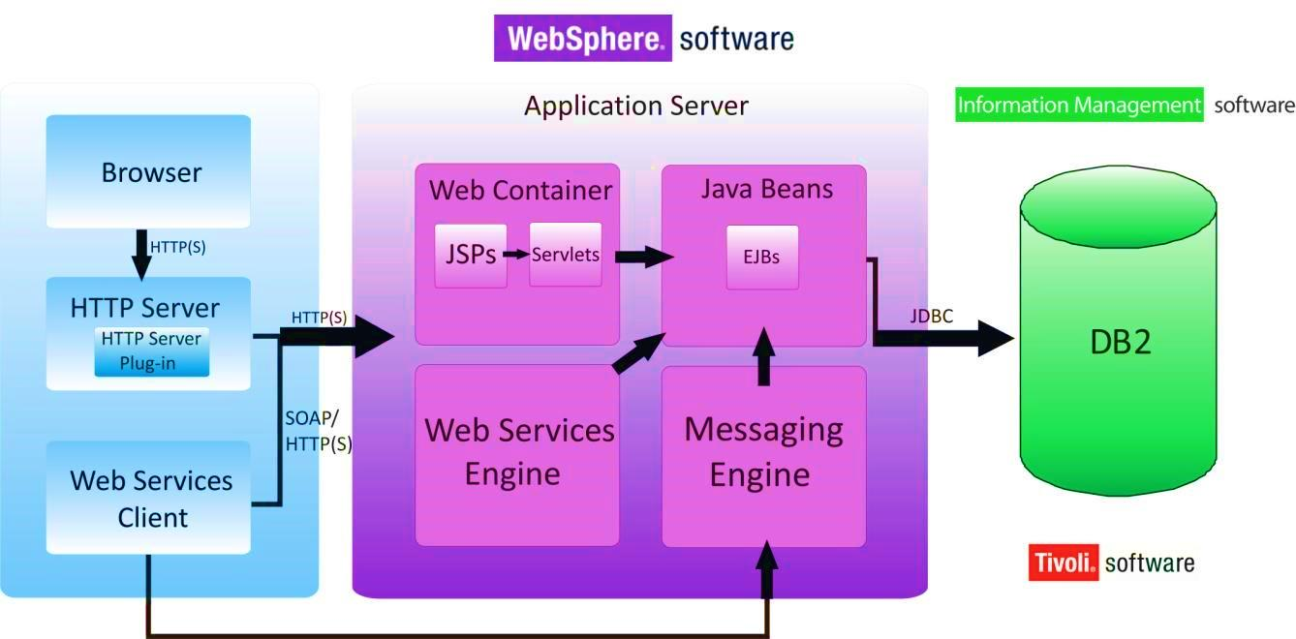

Fig 2.1: Product Perspective

## 

## 2.2 Software Interface Client on Internet

Web Browser, Operating System (any) **Client on Intranet**

Web Browser, Operating System (any)

**Web Server**

WASCE, Operating System (any)

**Data Base Server**

DB2, Operating System (any) **Development End**

RAD (J2EE, Java, Java Bean, Servlets, HTML, XML, AJAX), DB2, OS (Windows), Web Sphere(Web Server)

## 2.3 Hardware Interface

**Minimum Requirements:**

|  |  |  |  |
| --- | --- | --- | --- |
|  | Client Side |  |  |
|  | **Processor** | **RAM** | **Disk Space** |
| Internet Explorer - 6 | Intel Pentium III or AMD - 800 MHz | 128 MB | 100 MB |
|  | **Server Side** |  |  |
|  | **Processor** | **RAM** | **Disk Space** |
| RAD | Intel Pentium III or AMD - 800 MHz | 1 GB | 3.5 GB |
| DB2 - 9.5 | 256 MB | 500 MB  (Excluding Data Size) |

**Recommended Requirements:**

|  |  |  |  |  |
| --- | --- | --- | --- | --- |
|  | Client Side | | |  |
|  | **Processor** | **RAM** |  | **Disk Space** |
| Internet Explorer - 6 | All Intel or AMD - 1 GHZ | 256 MB |  | 100 MB |
| Web cam | 5.0 Megapixel Camera | | |  |
|  | **Server Side** | | |  |
|  | **Processor** | **RAM** |  | **Disk Space** |
| RAD | All Intel or AMD - 2 GHZ | 2 GB |  | 3.5 GB |
| DB2 - 9.5 | 512 MB |  | 500 MB  (Excluding Data Size) |

## 2.4 Communication Interface

User (Administrator, Jail Superintendent, CBI Officer, Police Officer, Judge) on Internet will be using HTTP/HTTPS protocol.

## 2.5 Constraints

* GUI is only in English.
* Login and password is used for the identification of users.
* Only registered users will be authorized to use the services.
* Limited to HTTP/HTTPS.
* This system is working for single server.

## 2.6 ER Diagram

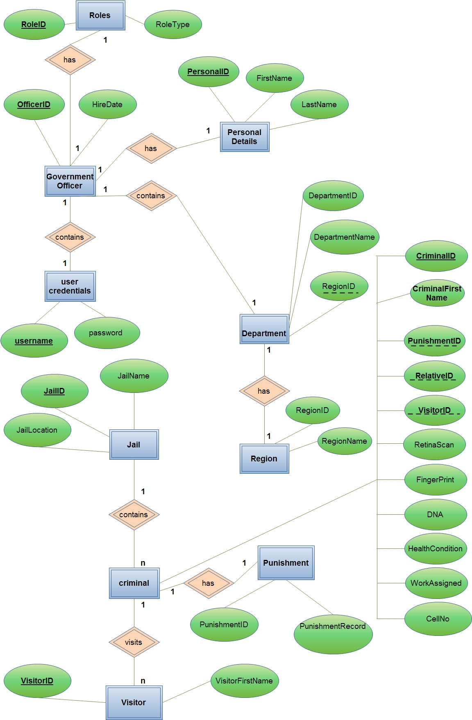

## 2.7 Use Case Reports

2.7.1 **Admin Use case Report**

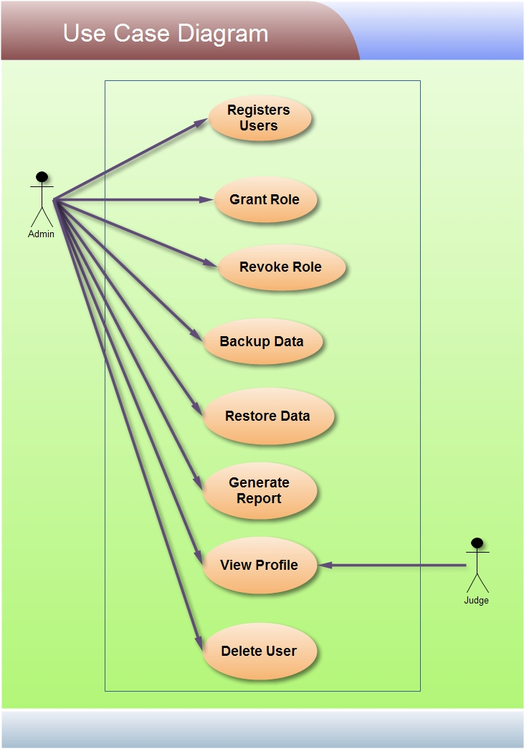

**Admin**:

Admin can register all the users (Jail Superidentent, Judge, Police Officer, CBI officer) , he can also delete the user. He can grant or revoke the roles to/from the users . He can store the data and he will generate the report.

**Judge:**

Judge can view the profiles of the users.

**2.7.2 Criminal Use Case Report**

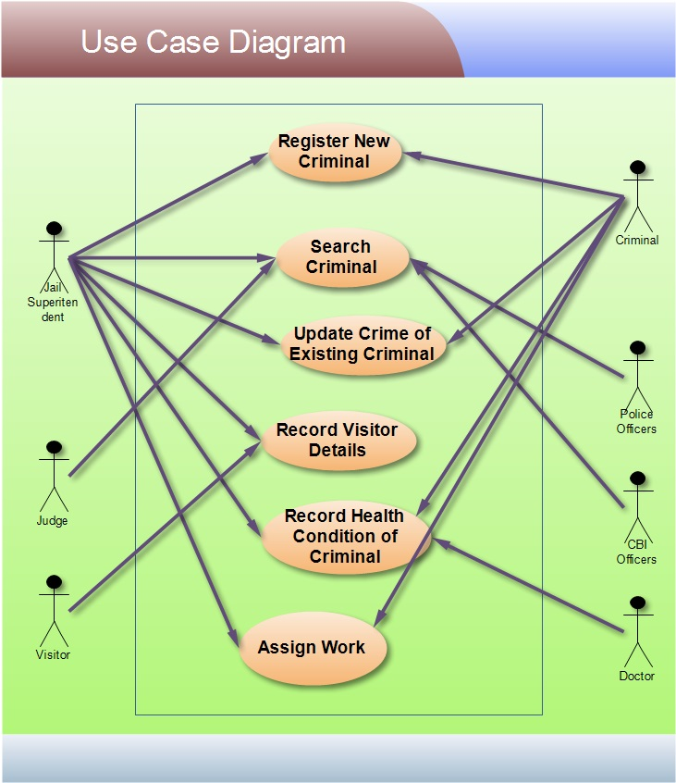

**Jail Superidentent:**

Jail Superidentent can register new criminal. He can search criminal by Id or Name. he can update the crime of existing Criminal . He will keep record of visitors and Health condition of Visitors. He will assign the work to criminals.

**Police Officer:**

Police Officer can search the criminal.

**CBI Officer:**

CBI officer can search the criminal.

**Judge:**

Judge can also search the criminal.

**Doctor:**

Doctor will keep record of Criminal’s Health Condition.

**2.7.3**

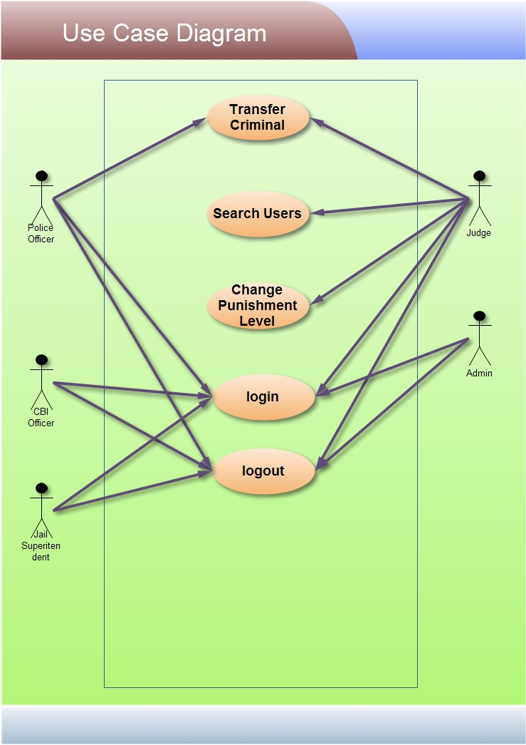

**Police Officer:**

Police officer can login or logout to system. He can transfer the criminal from one jail to another jail.

**Judge:**

Judge will give the order for transferring criminal from one jail to another jail. He can search Users (Police Officers, CBI Officers, Jail Superidentent). He can change the Punishment of Criminal.

## 3.1 Activity Diagrams

**3.1.1 User Registration Activity**

Initially user is made to fill all mandatory fields filled in registration form. Once the user clicks submit, the username is verified. If the username is already present, then the user is again taken back, so that he can change the username. If the username is not present then it checks for password and remaining mandatory fields. If any of the mandatory field is left empty or filled incorrect,then the user is informed to enter the correct values. Once all these verifications are succeeded, then the registration is done.

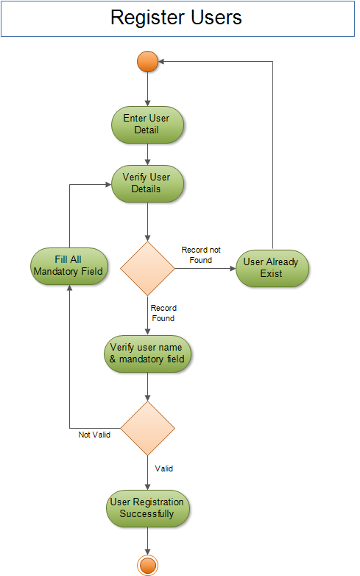

**3.1.2 Search Criminal Activity**

The User will enter the details of the criminal to search. Then the system will search the particular details and if the record is found then it will display corresponding information otherwise it will again ask for entering details.

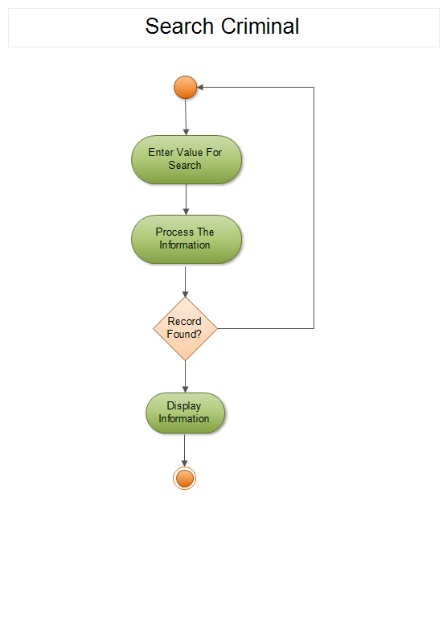

**3.1.3 Criminal Registration Activity**

Jail Superidentent will enter the details of the Criminal like name, Blood group, DNA details.

System will verify all the details that are entered. If the details are valid, then criminal will be registered otherwise jail Superidentent have to enter the details again.

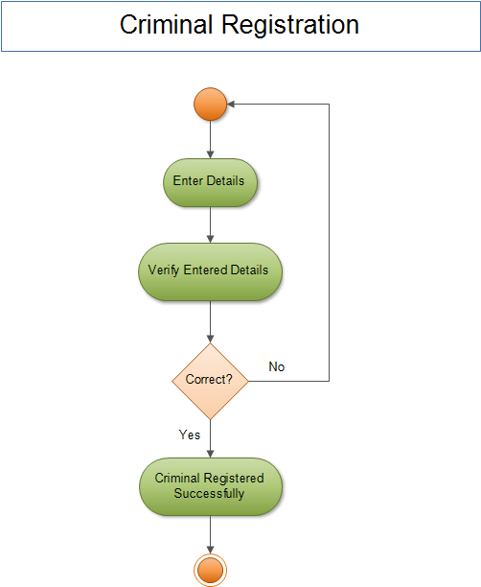

**3.1.4 Records Visitors Details Activity**

Jail Superidentent will keep record of Visitors details. He will enter details and system will check the details, if the details are correct then Visitors details will be saved.

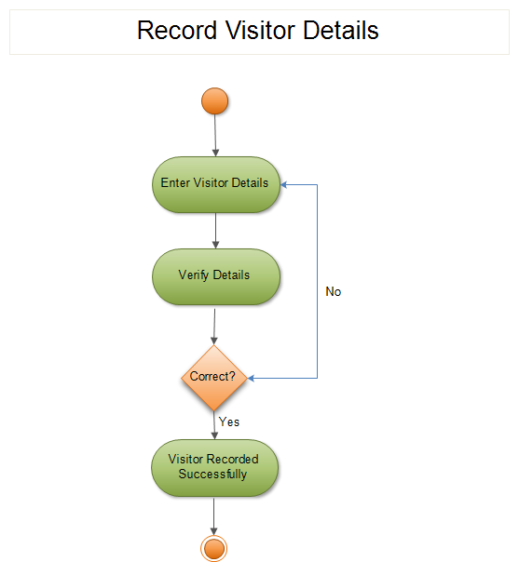

**3.1.5 Update Crime of Existing Criminal Activity**

Jail Superidentent will search for the criminal, and then he will update the crime of existing criminal.

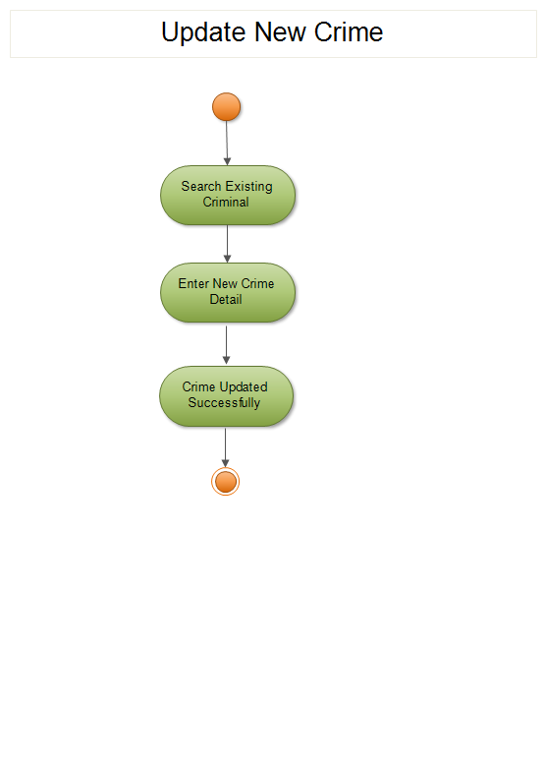

**4.0 Class Diagram**

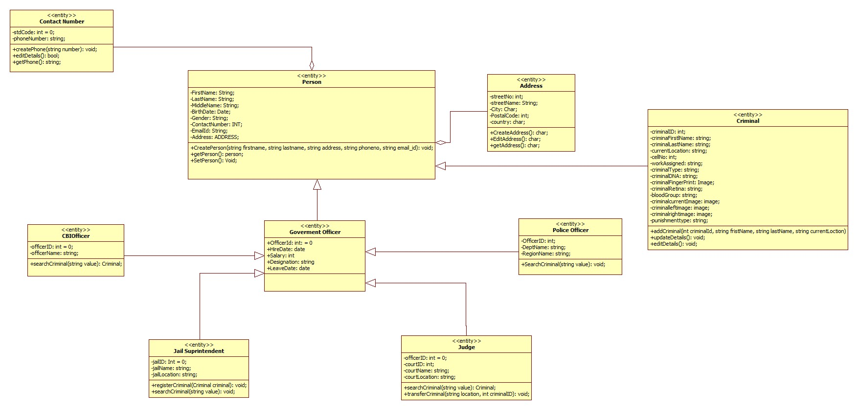

Above figure represents class diagram for CRM.

Here , the person class is the base class which will contains all the information about persons and then criminal, jail Superidentent, Police Officer, CBI officer, judge all these classes are inherited from the base person class.

All the derived classes have some specific functionality depending upon its roles.

The person class has Address and Contact No. Address and Contact No are classes over here.

**Special Thanks**

We convey a special thanks to our department and to our college. We also convey a special thanks to all these software’s and websites, they have been helping a lot in doing the project.



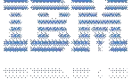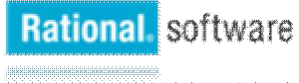

*Page*